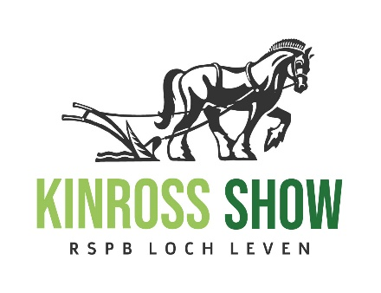
KINROSS-SHIRE AGRICULTURAL SOCIETY
Registered SCIO known as Kinross Show
Charity Number SC049394
Loanhead Farmhouse
Sheardale
Dollar
FK14 7LY
Tel: 07871 657439
Email – kinrossshow@gmail.com
Web: www.kinross-show.co.uk
KINROSS-SHIRE AGRICULTURAL SOCIETY

FAMILY MEMBERSHIP FORM – 2024

Name : __________________________________________________________

Address : __________________________________________________________

__________________________________________________________

Email address : __________________________________________________________

Please enter the names of all members joining  Adult (16 and over) Child (no older than 12 on show day) | Adult - £15  Child - £3
If you would like your badges sent to you, please add £1 towards postage costs.
(Up to 30th June only)
Donation – this is optional but any donation is gratefully received.

Total Payment Due

Payments preferred by bank transfer where possible:
Kinross-shire Agricultural Society
Sort Code 83-23-47 Account Number 00656030

