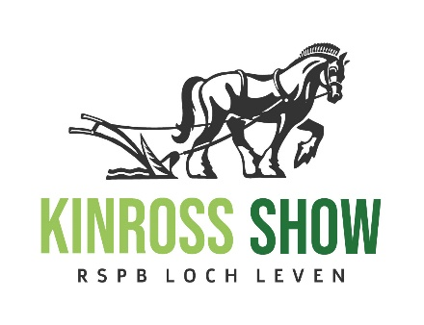
KINROSS-SHIRE AGRICULTURAL SOCIETY
Registered SCIO known as Kinross Show
Charity Number SC049394
Loanhead Farmhouse
Sheardale
Dollar
FK14 7LY
Tel: 07871 657439
Email – kinrossshow@gmail.com
Web: www.kinross-show.co.uk
KINROSS-SHIRE AGRICULTURAL SOCIETY

MEMBERSHIP FORM – 2024

Name : _____________________________________________________

Address : _____________________________________________________

Email address : _____________________________________________________

Please enter the names of all members joining  Adult (16 and over ) Youth (13-15 years) | Adult £15  Youth £3
If you would like your badges sent to you, please add £1 towards postage costs.
(Up to 30th June only)
Donation – this is optional but any donation is gratefully received.

Total Payment Due

Payments preferred by bank transfer where possible:

Kinross-shire Agricultural Society
Sort Code 83-23-47
Account Number 00656030

Cheques to: Loanhead Farmhouse, Sheardale, Dollar, FK14 7LY

